**Java 1: Assignment #2**

Due: TBD

Please remember to read over the assignment rubric before answering these questions. Each question should be written in its own file for upload. When all questions are answered place the source code for each question in a folder, zip it up, then upload it to the assignment 2 upload area on the LMS. If there are any concerns, let me know right away. Feel free to work with others to solve the questions but please code them on your own.

**Question 1: [10 marks]**

Write a Java program that can be run by command prompt where the user can enter in CMD the number of words to enter. Notice in the screenshot the number three after Question1 Java class, this is the parameter sent to the main method. It must be parsed to an integer as the main method accepts parameters as an array of strings. Once the user enters all three words/sentences the program will randomize the words stored in its array, then will print out the randomized array of strings character by character.

Here is an example of the program output:

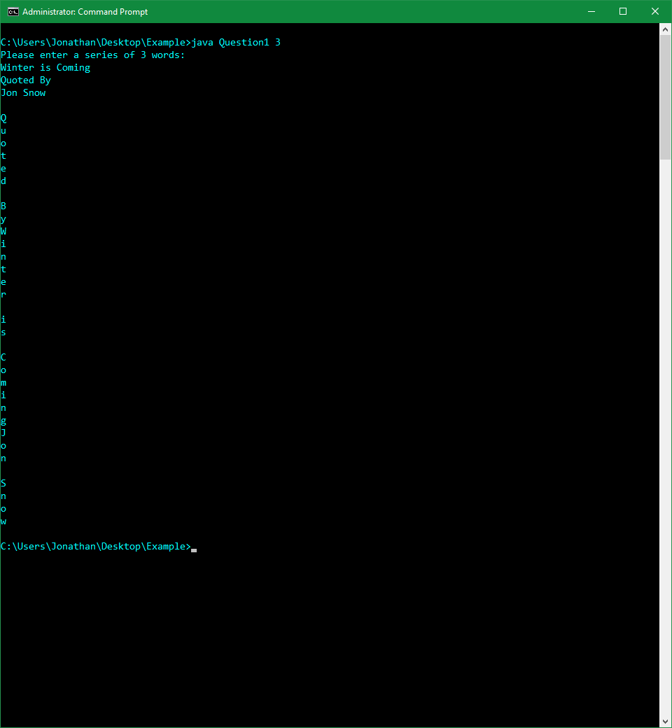

**Question 2: [15 marks]**

Write a program that will ask the user whether they want to compare two arrays from separate files. If the user selects ‘Y’ the program will proceed to ask the user to select two separate files using a JFileChooser. The two files must be text files, contain a list of integers, and have the same number of integers. The very first line of the text files will be an integer denoting how many integers exist in the file and the last line will be a string indicating it is the end of the file. Once the values are read in from the files into two separate arrays use the Arrays.sort() methods to sort both arrays, then Arrays.Equals() to check for equality. Indicate when the program has successfully terminated. If the user selects ‘N’ simply terminate the program.

Here is an example of text files and program output:

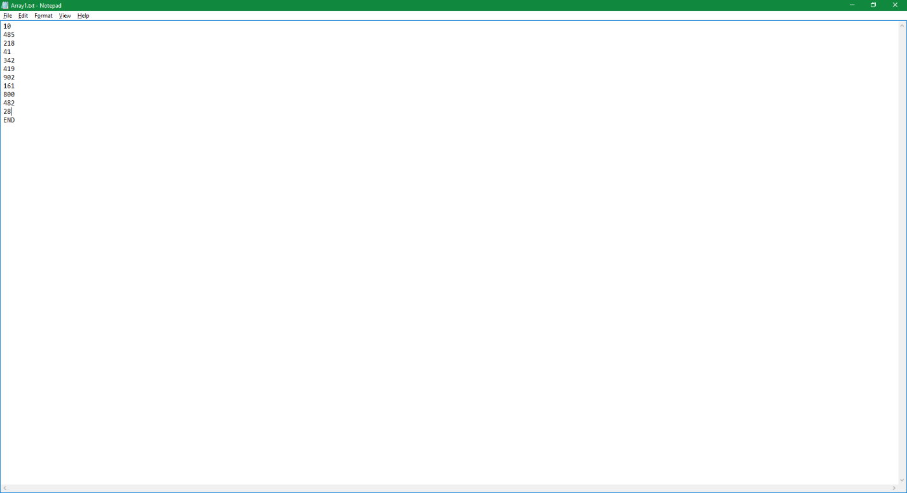

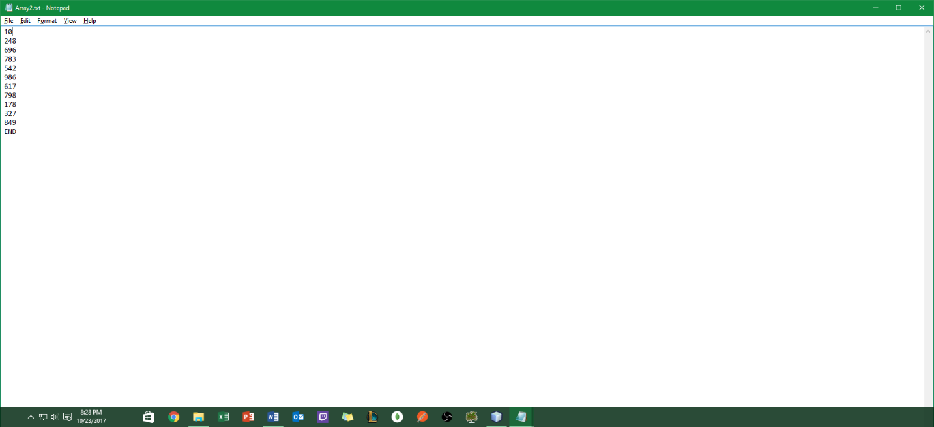

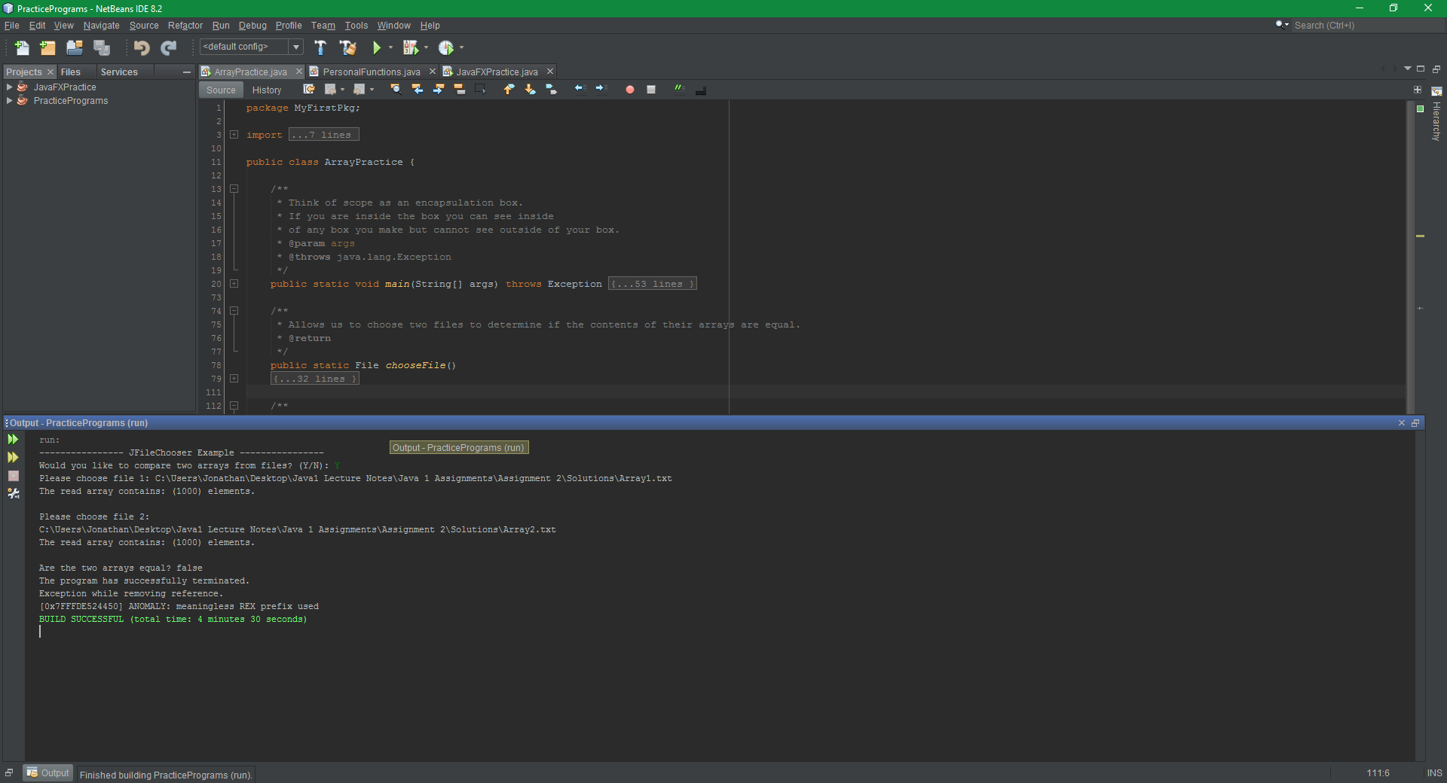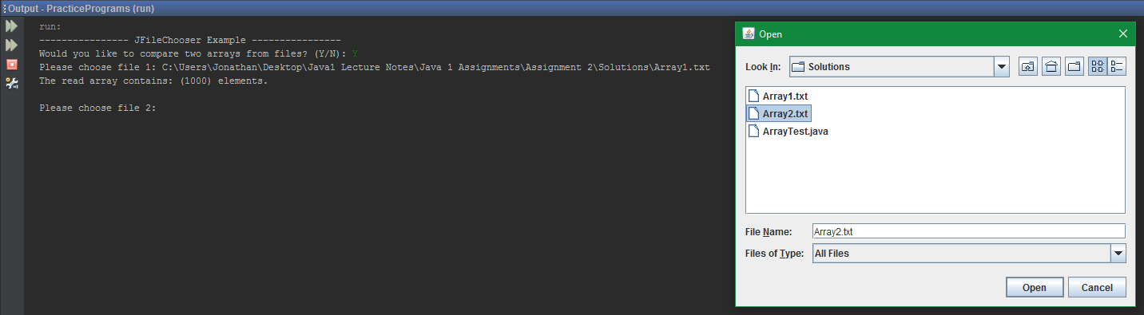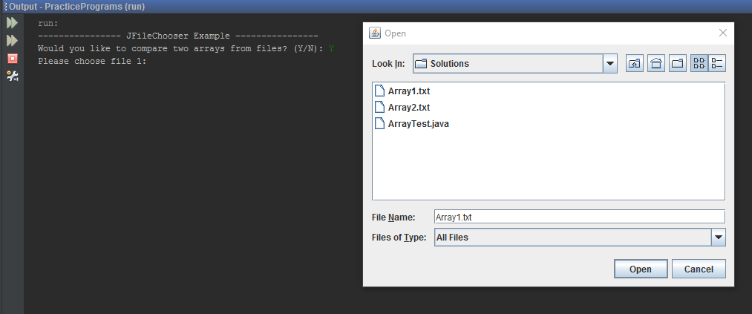

**Question 3: [10 marks]**

Write a program that will prompt the user to enter a number of students and a number of tests. These values will be used to set the rows and the columns of a 2D array. The rows of the 2D array represent the number of students while the columns represent each test the students have written. The program should be able to perform the following functions (each should have its own method):

1. Populate the student’s grade data.
2. Print the students test grades.
3. Calculate and print the test’s averages.
4. Calculate and print the student’s averages.

Please be sure to test values with a different number of students and tests for validation.

Here is an example of the program output:

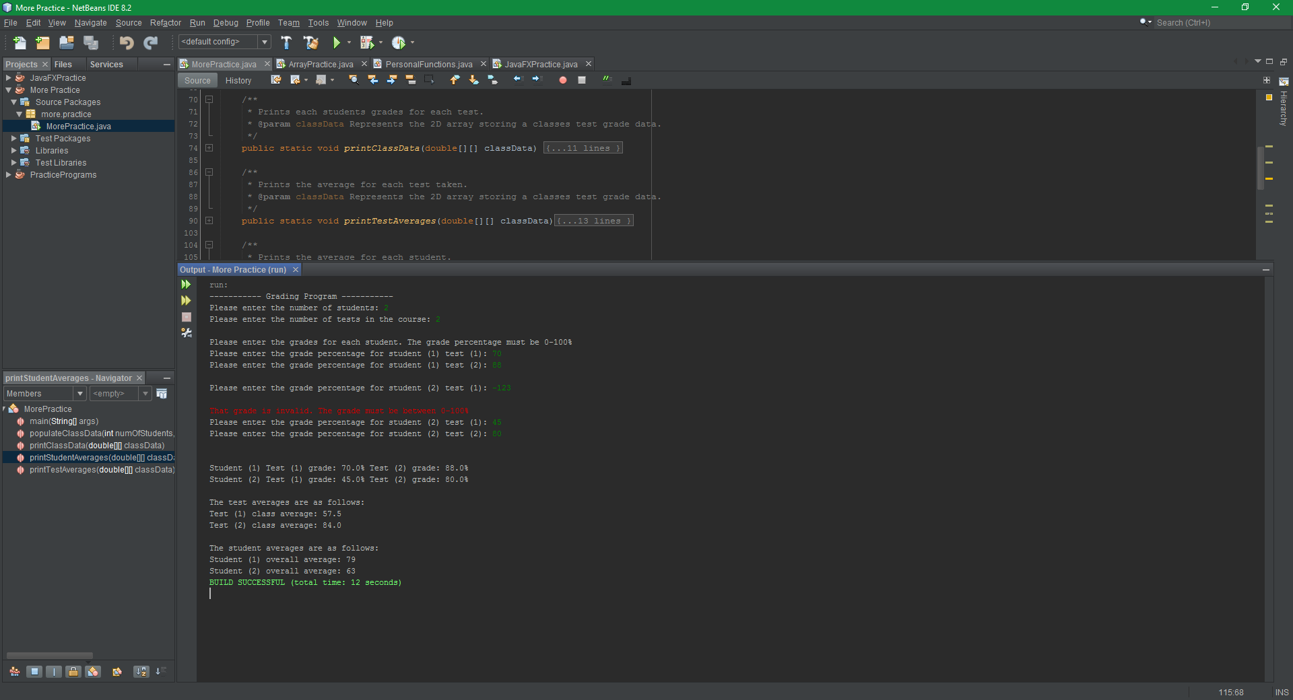

**Question 4: [15 marks]**

Create a different package in the directory structure of your IDE. Name this package Models. In this new package, create three separate classes representing the following 2D shapes:

1. Rectangle. (Length and width)
2. Triangle (Base and height)
3. Circle (Radius)

Each class should have a constructor accepting the dimensions of each shape, associated getter, and setter methods for modifying and retrieving shape data, a method to print the area of each shape, and a method to display the dimensions of each shape. Each class should also keep track of how many of each shape is created. When creating the objects of each class create at least two objects of each and demonstrate the use of each of the class’s methods.

Here is an example of the program output:

